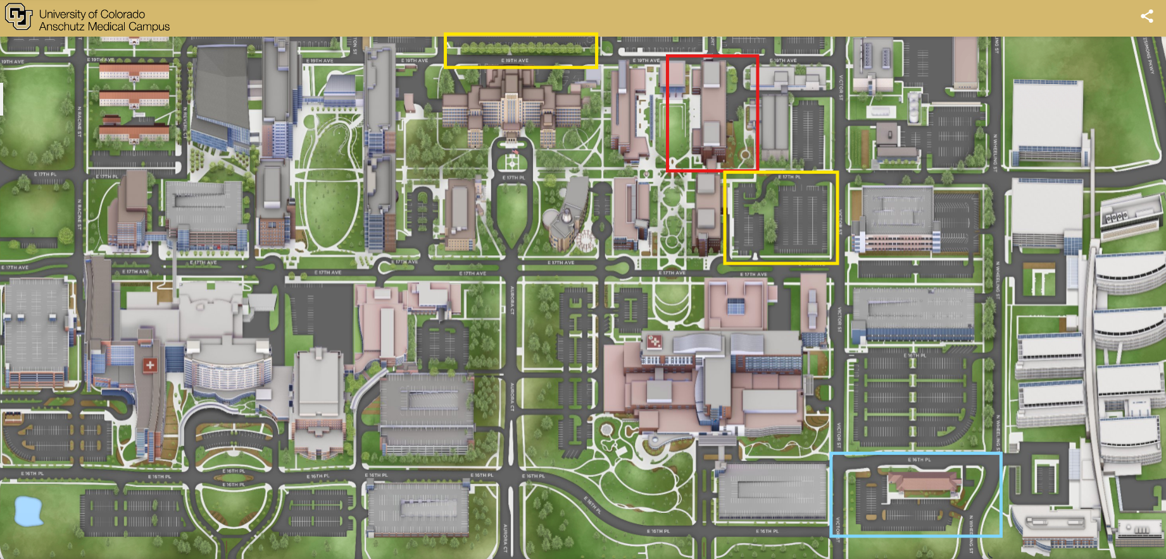
*Look at different color square legions on the map

Classroom Lecture – Meet at Ed2N P28 building (Education 2 North; Physical address: 13120 E 19th Ave, Aurora, CO 80045) in the morning on:
- Tuesday, September 23, 2025
9:00 AM - 4:00 PM Essential Newborn Care Course - Ed2N P28-2102
- Wednesday, September 24, 2025
9:00 AM - 4:00 PM Essential Newborn Care Course - Ed2N P28-1102
- Thursday, September 25, 2025
8:00 AM - 4:00 PM Essential Newborn Care Course - Ed2N P28-1206

Meet at the Simulation Center in the afternoon on 9/23, 9/24, and 9/25 to continue hands on activities. Physical Address: 1575 N Wheeling St (1575 N Wheeling St, Aurora, Colorado 80045). Parking in this lot is free.

“Kiowa Vistor & Patient Parking”. This is the closest parking lot to the Ed2N P28 building. Parking cost is $1 USD per hour. Please see instructions below.
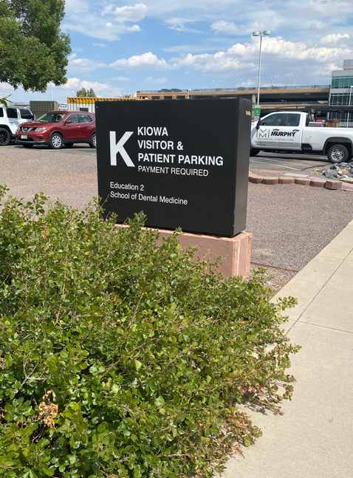
Picture above is the closest parking lot to the Ed2N P28 building, “Kiowa Visitor & Patient Parking”.
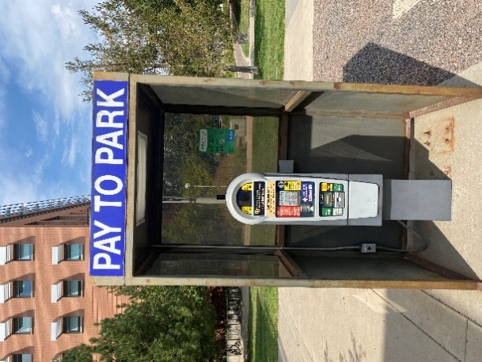
Please pay for parking or you will get a ticket. Pay at the “PAY TO PARK” booth. You will enter your car plate information and press “NO” for parking code. After parking, you will walk to the Ed2N P28 building (Physical address: 13120 E 19th Ave, Aurora, CO 80045). This is a short 1–3-minute walk.
You can also park behind the Fitzsimons Building on CU Anschutz Medical Campus. The physical address is 13001 E 17th Pl, Aurora, CO 80045 and it’s also marked in a yellow square above.
There is FREE parking at the Simulation Center (Physical address: 1575 N Wheeling St, Aurora, Colorado 80045). The walk from the Simulation Center to Ed2N P28 is approximately 10 minutes. If you decide to park here, please park against the building so you will not interfere with valet.

